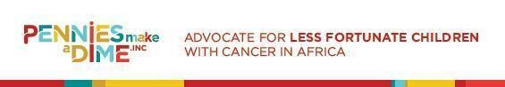
PMAD 3nd Annual Keep Hope ALive Fundraiser Gala.
Saturday, July 29, 2023 Hockessin Memorial Hall / Hockessin, DE
Sponsorship Levels 2023 / Deadline: Tuesday, July 29, 2023
All Event Sponsors Receive:
● Verbal recognition form the podium at opening plenary
● Company name included on print & email invitations,
● Top- tier logo recognition on website, advertising, social media and promotional material
● Listing in the PMAD Inc. National Annual Report, distributed to 30 communities nationwide.
❖ Diamond Sponsor: $3,000
● Name and logo on event invitation
● 5 tickets for the event
● 1.5 minute on-screen logo inclusion
● Program cover ad, full page color on back
or inside cover (8” x 5”)
❖ Platinum Sponsor: $2,000
● Name and logo on event invitation
● 3 tickets for the event
● 1minute on-screen logo inclusion
● Full page color ad (8” x 5”)
●
❖ Gold Sponsor: $1,000
● Name and logo on event invitation
● 2 ticket for the event
● 1 minute on-screen logo inclusion
● Full page black & white ad in program (8.75” x 5”)
❖ Silver Sponsor: $750
● Name on event invitation
● 1 tickets for the event
● 1 minute on-screen logo inclusion
● Half page black & white ad in program (3.75” x 5”)
❖ Bronze Sponsor: $350
● Name on event invitation
● 1 ticket for the event
● Quarter page black & white ad in program (3.75” x 2.5”)
If you do not see what you are looking for here, our team will assist you in customizing a sponsorship package that specifically fits your publicity budget For more information Contact: Patience Roberts
penniesmakeadime@gmail.com
274 Oakfield Drive, Newark, DE 19713 EMAIL: info@penniesmakeadime.org: www.penniesmakeadime.org
Sponsorship Agreement Form
Please accept our sponsorship at the following level
❏ Diamond Sponsor: $3,000
• Name and logo on event invitation
• 5 tickets for the event
• 1.5 minute on-screen logo inclusion
• Program cover ad, full page color on back
or inside cover (8” x 5”)
❏ Platinum Sponsor: $2,000
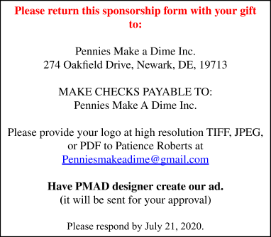
• Name and logo on event invitation
• 3 tickets for the event
• 1minute on-screen logo inclusion
• Full page color ad (8” x 5”)
❏ Gold Sponsor: $1,000
• Name and logo on event invitation
• 2 tickets for the event
• 1 minute on-screen logo inclusion
• Full page black & white ad in program
(8.75” x 5”)
❏ Silver Sponsor: $750
• Name on event invitation
• 1 tickets for the event
• 1 minute on-screen logo inclusion
• Half page black & white ad in program
(3.75” x 5”)
❏ Bronze Sponsor: $350
• Name on event invitation
• 1 ticket for the event
• Quarter page black & white ad in program
(3.75” x 2.5”)

Please print your name as it should be published in our donor lists.
Company: __________________________________________________________________ Contact Name: ______________________________________________________________ Title: ______________________________________________________________________ Address: ___________________________________________________________________ City: _____________________________________ State: ________ Zip Code: ___________ Phone Number: _________________________ Email Address: _______________________
SIGNATURE: __________________________________ DATE: _____________________________
274 Oakfield Drive, Newark, DE 19713 EMAIL: info@penniesmakeadime.org: www.penniesmakeadime.org

